Korean-American Construction Engineering and Project Management Association (KACEPMA)

Inaugural Meeting Minutes

Date and Time: January 10, 2013, 2013, 5:00 PM – 7:00 PM.
Location: Hyatt Regency Orange County, 11999 Harbor Blvd., Garden Grove, CA 92840
Participants: See the attached attendance sheets

- Dr. Hyungseok Jeong (Iowa State) called the meeting to order

- Dr. HyunJoo Kim (University of North Carolina – Charlotte), the chair of the 5th ICCEPM conference, started the meeting with welcoming remarks and mentioning the significance of the meeting to the Korean American scholars in the field of construction, engineering, and project management.

- Dr. Young Hoon Kwak (The George Washington University) spoke about the history of Korean American scholars in this field and efforts made until this historical inaugural meeting came to realization.

- Every attendee was given an opportunity to introduce themselves. Even though this self-introduction of attendees took a lot longer than expected, it was a valuable time to get to know each other and feel as a member of one community.

- Dr. Yesang Kim, the president of Korean Institute of Construction Engineering and Management (KICEM), talked about the excitement that this new association is creating for the Construction Engineering and Project Management (CEPM) professionals working in the U.S. and Korea. He praised the efforts of the founding members and envisioned that this new association would be able to work as an excellent bridge to connect the CEPM professionals in both countries for mutual benefits and the professional advancements. He also gladly donated $1,000 in a form of scholarship to KACEPMA as the president of KICEM.

- Two doctoral students, Mr. Sanghyung Ahn (Purdue University) and Mr. Haegon Kim (University of Texas, Austin) were awarded the KACEPMA-KICEM scholarship for their voluntary work in developing the KACEPMA website (www.kacepma.org). They have been working with Dr. Yong Kwon Cho since May 2012 and will continue to work as the website development committee members.
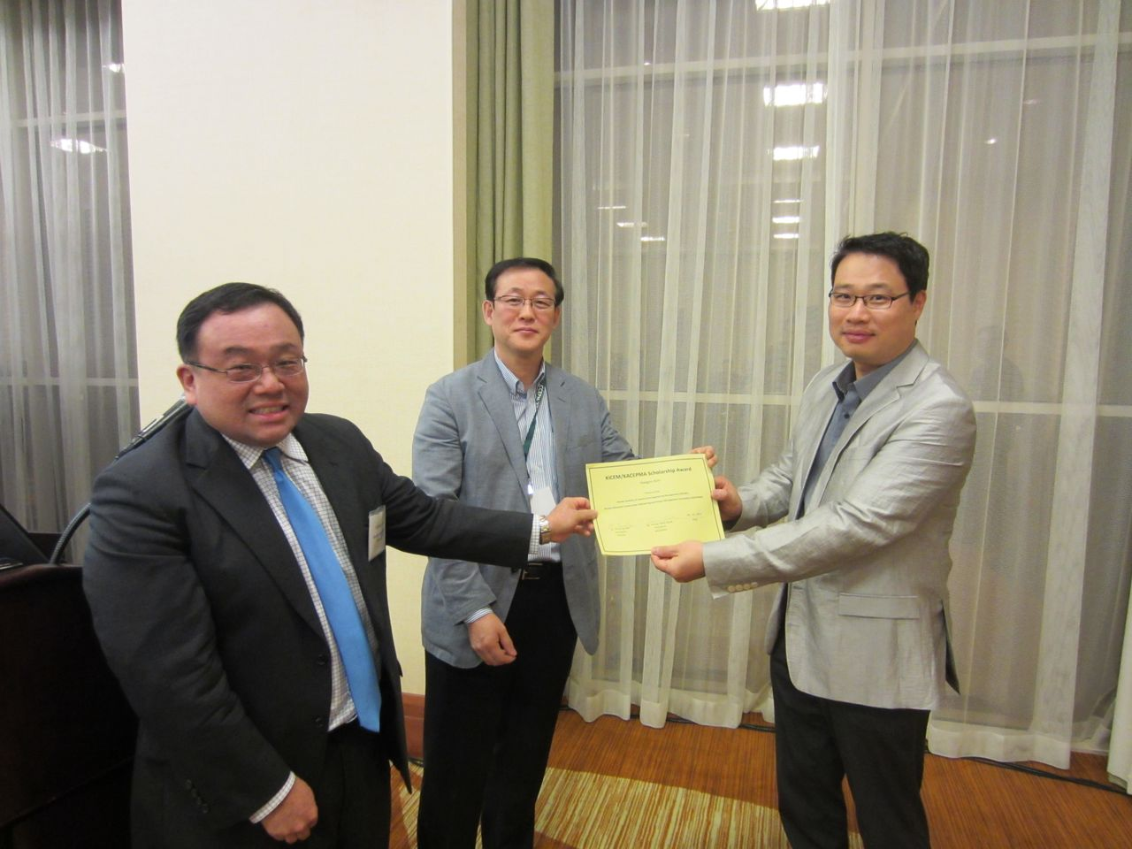
Scholarship Award Presentation
(Dr. Cho received the awards on behalf of two awardees)
- The activities of the three committees and their progresses were reported at the meeting. Dr. Joohyoung Lee asked for more active participation in sharing CEPM course materials. He handed out a note encouraging the members to participate in the development of the course material database (please see the attached). Dr. Yong Kwon Cho reported on initial activities of his research committee and the website development committee. The committee members were introduced. He asked the members to register at the KICEPMA website. He demonstrated the registration process and during the registration process, the research interest areas of a member can be filled out, and later on, this information will be shared among members for finding potential research collaborators. This registration process is also linked with the KSEA membership registration process. Dr. HyungSeok Jeong explained that the KSEA membership is important for the KACEMPA to stay and be connected to KSEA as an Associated Professional Society (APS) and to obtain financial support from KSEA.

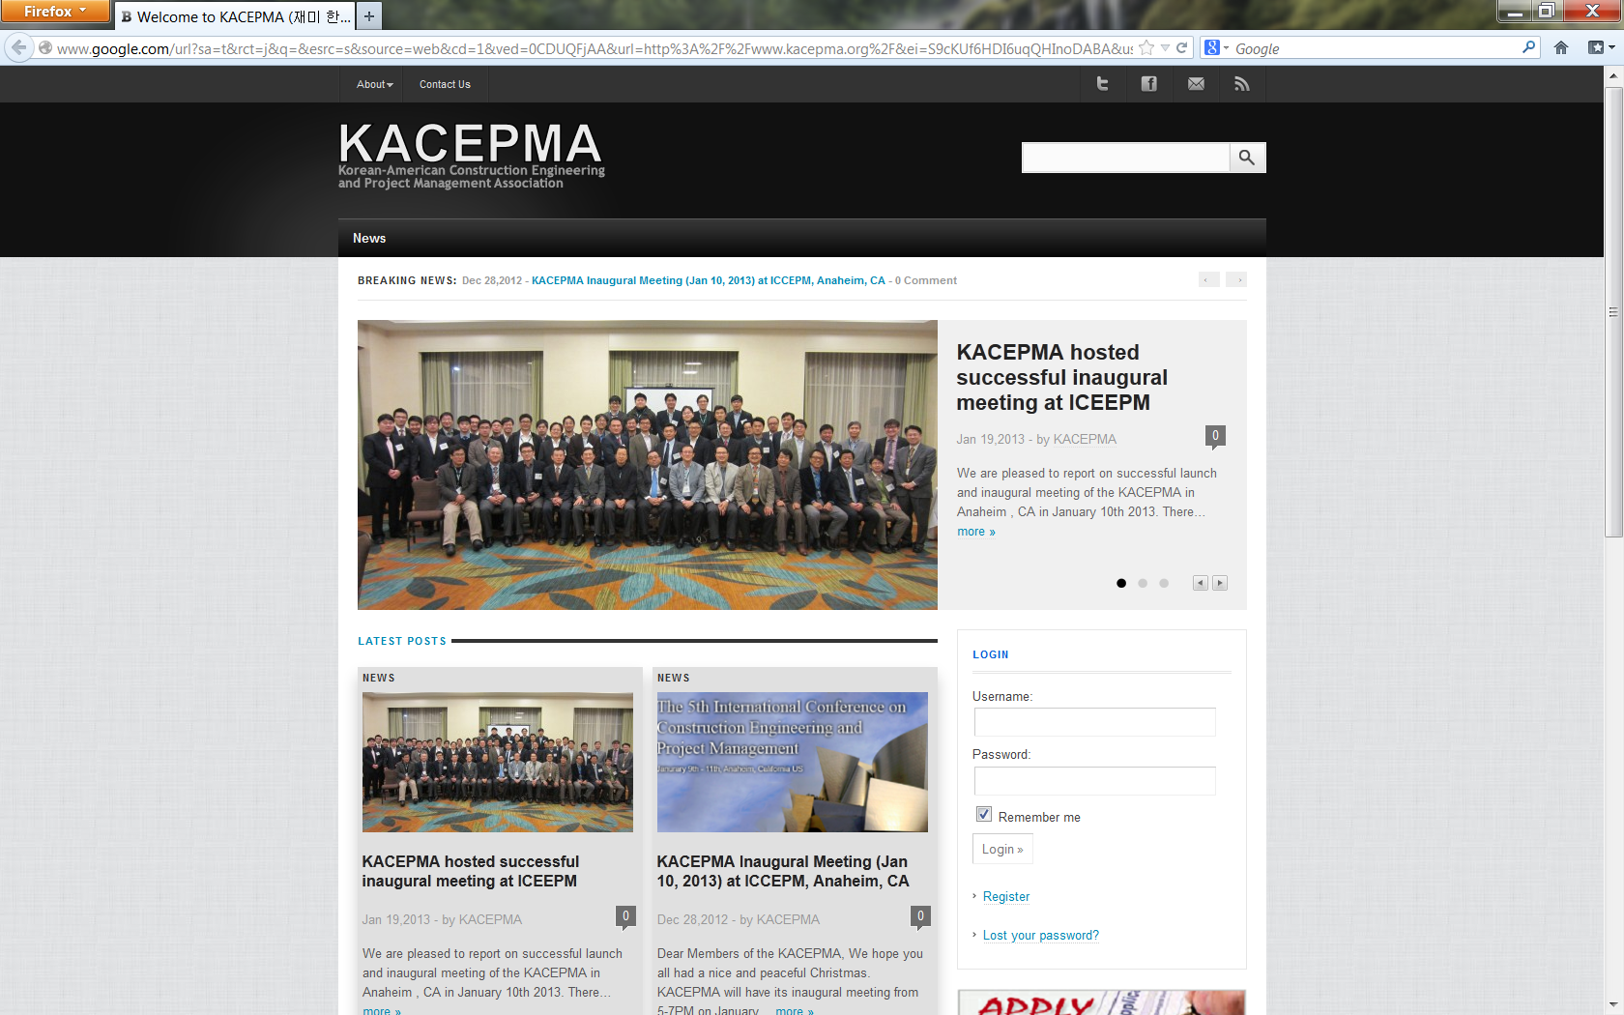

KACEPMA Website

- A short video clip highlighting 2011 UKC (http://www.youtube.com/watch?v=GR_qNBO4OB0) was also shown. Dr. HyungSeok Jeong encouraged the meeting attendees to participate in various activities sponsored by KSEA including the UKC 2013 conference, Sheraton Meadowland, NJ August 7-10, 2013.

- Two researchers from the Korean Institute of Construction Technologies (KICT), Dr. Heisook Nah and Mr.KiBeom Ju gave an invited presentation on “The State of the Art of Road BIM development in Korea.” The KICT is the largest government sponsored research institute in the area of construction engineering and management and it has high potential for KACEPMA members to collaborate in various aspects in the future. This presentation gave an opportunity for the meeting attendees to think about collaboration potentials with the KICT.

- Finally, the KACEPMA was inaugurated and officially launched with the three leadership positions elected. Dr. Young Hoon Kwak was floor-nominated as the first President of the Association and was unanimously approved. Dr. Kwak selected Dr. Yong Kwon Cho as vice president and Dr.HyungSeok Jeong as secretary in his leadership team of the association. According to the bylaws, the president’s term is one year and the vice president and the secretary will be automatically promoted to the upper position in the following year. A new secretary will be elected at every annual meeting.

- A group photo of all the attendees was taken.

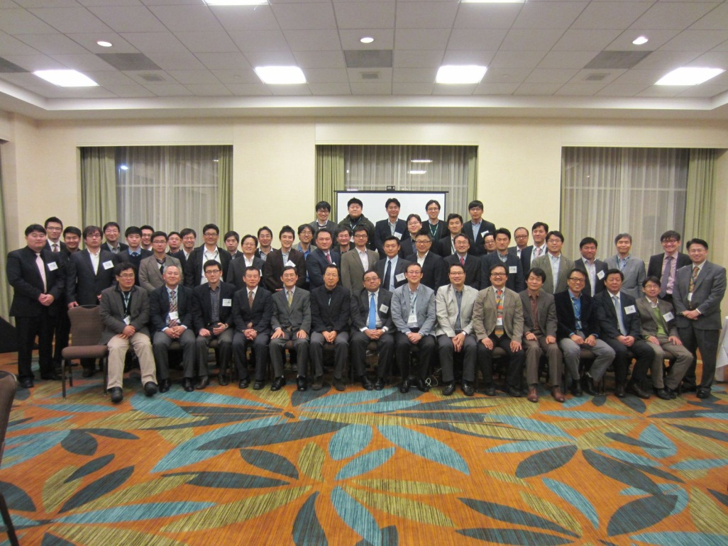

- The meeting was adjourned by Dr. Young Hoon Kwak

Note from Dr. JooHyoung Lee (Education Committee Chair)
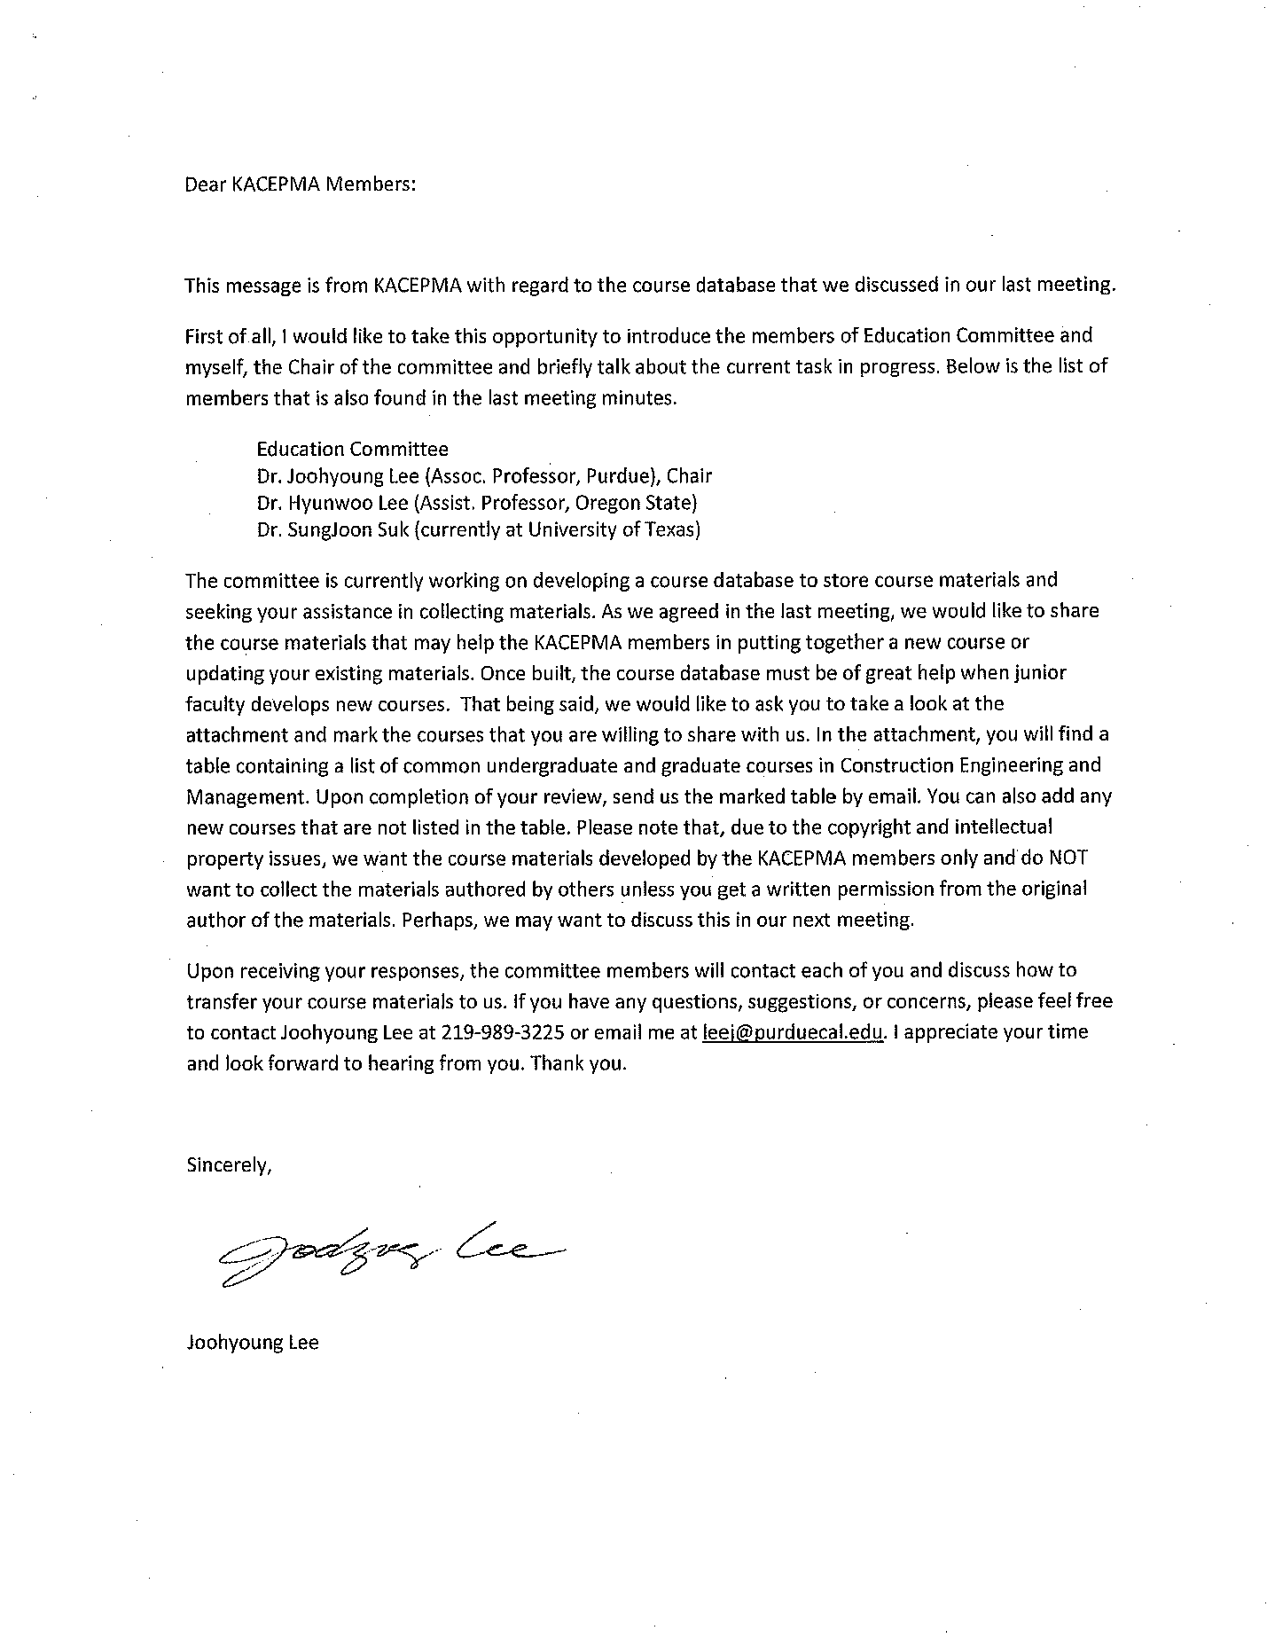
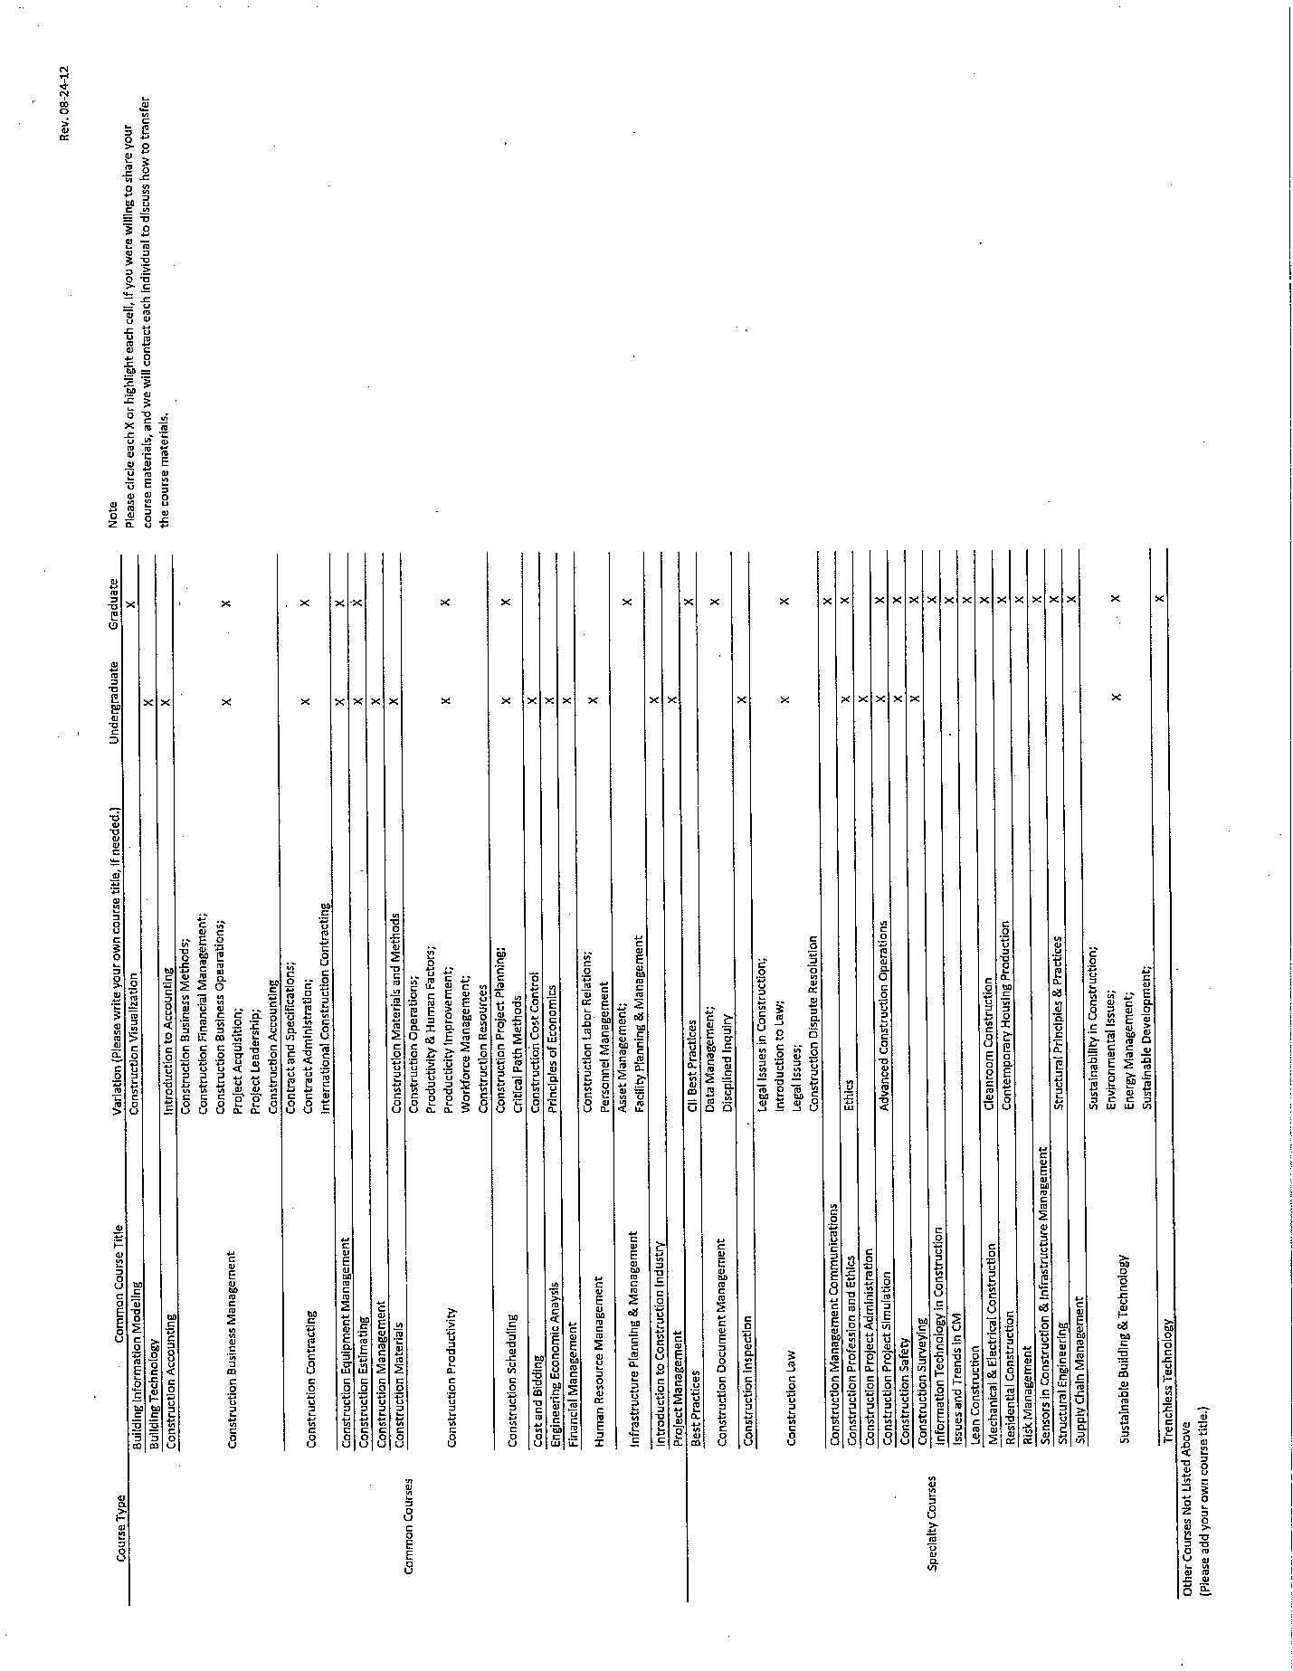

Appendix D. Inaugural Meeting Attendance Sheets
